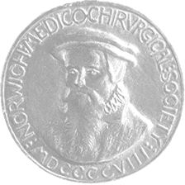

Carlile Prize – Application Form
Norwich Medico-Chirurgical Society

Invitation for Applications
The Norwich Medico-Chirurgical Society invites applications from Resident Doctors and Medical Students for the Carlile Prize. Shortlisted applicants will be invited to present original research at an evening Norwich Medico-Chirurgical Society meeting.
Presentations will take place at The Gooch on Thursday 14 May 2026 from 6:00 PM.
Research should be recent and include a strong component based in Norfolk, either from hospital practice or primary care.
Entries will be judged by a panel of doctors on originality, content, and presentation. The winning candidates will receive a share of the £600 prize fund.

Application Details
To apply, please complete the form below and submit it together with your research abstract (maximum 250 words).
Submit applications by email to: doreenmedchi@gmail.com
Closing date for applications: Friday 10 April 2026

Carlile Prize – Application Form

Applicant Information
Author's Name
Current Post / Role
Telephone Number
Email Address

Presentation Details
Title of Presentation
Name of Supervisor and Specialty

Research Abstract (Maximum 250 words)

Word Count:

Norwich Medico-Chirurgical Society – Carlile Prize
More information on the history of the Carlile Prize can be found on our website
norwichmedchi.org.uk

